`
MINERVA INTERNATIONAL FREIGHT FORWARDERS ASSOCIATION
Annual General Meeting will be held at
Sheraton Grand Hotel ***** Deluxe
Dubai, UAE, 7 to 10 April 2019

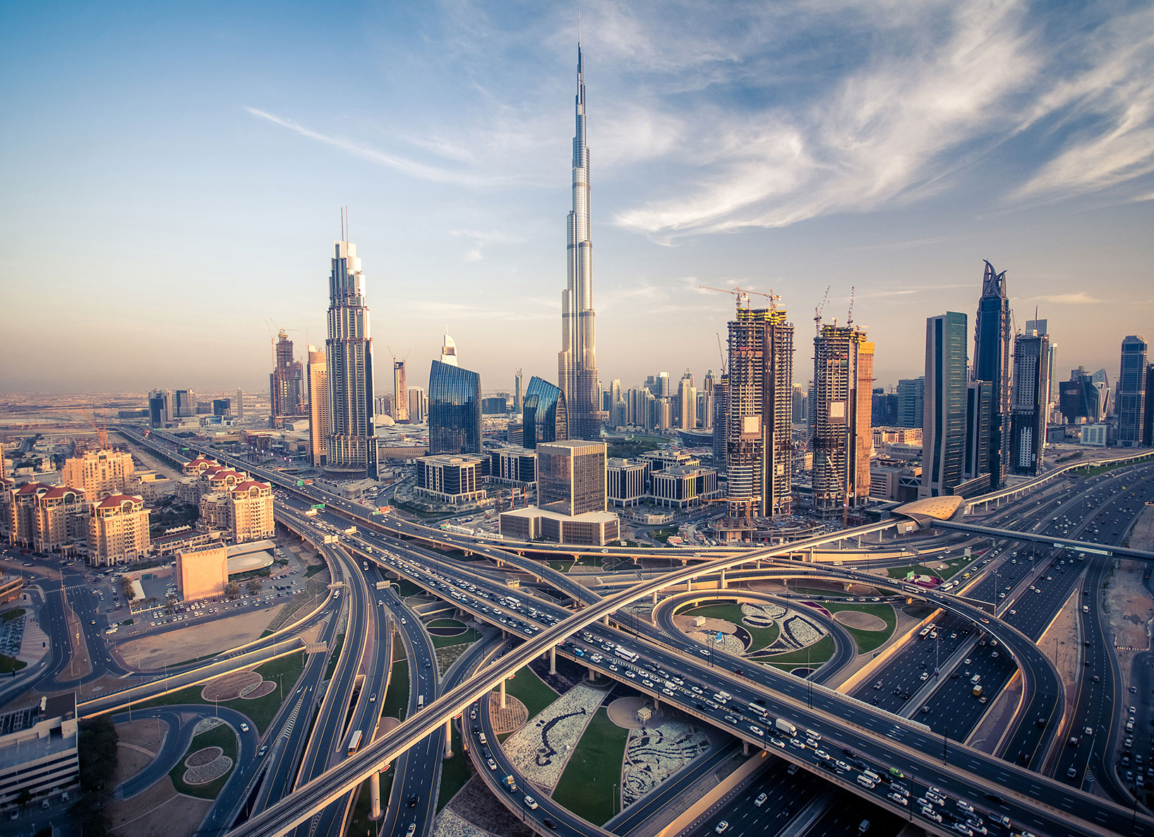

HOTEL NAME :SHERATON GRAND HOTEL 5 star hotel deluxe
Location : 3 Sheikh Zayed Road, Dubai, UAE

____________________________________________________________________________
MIFFA INTERNATIONAL NETWORK
WORLDWIDE CONFERENCE
DUBAI, UAE, 7 to 10 April 2019
Page 1 of 10

REGISTRATION FORM

COMPANY NAME : ___________________________________________________________

NAME PARTICIPANT’s : ___________________________________________________________

ADDRESS : ___________________________________________________________

COUNTRY : ___________________________________________________________

VAT NUMBER : ___________________________________________________________
PERSON IN CHARGE OF MAKING RESERVATION

Name :___________________________________________________________

Company Name :___________________________________________________________

Phone/Mobile :___________________________________________________________

Email address : ________________________________________________________________

Comments:

____________________________________________________________________________
MIFFA INTERNATIONAL NETWORK
WORLDWIDE CONFERENCE
DUBAI, UAE, 7 to 10 April 2019

Page 2 of 10

ALL – IN PACKAGE PRICE
Covering 3 nights hotel stay

Sheraton Grand Hotel 5 star hotel Sheikh Zayed Road
Delegate Rate Run of the house subject to availability
Deluxe Single Room – USD$ 2642.00 per person
Double Room 2 attendant sharing – USD$ 2255.00 per attendant on Double Sharing basis
Double – Attendant + Spouse
Double Room attendant and spouse sharing – USD$ 3475.00 per couple on Double Sharing basis
Delegate Rate Run of the house subject to availability
Club Single Room – USD$ 2759.00 per person
Club Double Room 2 attendant sharing – USD$ 2360.00 per attendant on Double Sharing basis
Club Double – Attendant + Spouse
Club Double Room attendant + spouse sharing – USD$ 3685.00 per couple on Double Sharing basis
Delegate Rate Run of the house subject to availability
Executive Suites Single Room – USD$ 3326.00 per person
Executive Suites Double Room 2 attendant sharing – USD$ 2645.00 per attendant on Double Sharing basis
Executive Suites Double – Attendant + Spouse
Executive Suites Double Room attendant + spouse sharing – USD$ 4255.00 per couple on Double Sharing basis

____________________________________________________________________________
MIFFA INTERNATIONAL NETWORK
WORLDWIDE CONFERENCE
DUBAI, UAE, 7 to 10 April 2019

Page 3 of 10

Room rate Extra night charge per room per night inclusive tax and Dirham Tourism fee
Single/Double Deluxe Room on BB – USD$ 225.00 per room per night
Club Room Single Room on BB – USD$ 264.00 / Double Room on BB – USD$ 295.00 per room per night
Executive Suites Single Room on USD$ 453.00 / Double Room on BB – USD$ 485.00 per room per night
ANNEX A: Delegate Inclusive of
- 3 nights hotel stay with breakfast at the hotel
- Room rates with breakfast at the hotel | municipality tax | service tax | Vat 5% | room wifi internet| dirham tourism fee.
- Welcome Reception Yacht Cruises Sunday on the 7th April 2019.
- 1 Full Day meeting Starlight Ballroom Monday on the 8 April 2019 with 2 coffee break per day, buffet lunch, water, soft drinks, tax, service charge and VAT 5%
- 1 Dinner 4 course menu at Thiptara Restaurant The Palace on the Monday 8th April 2019
- Desert Safari with BBQ Dinner Tuesday on the 9th April 2019 – Sponsored by Phoenix Shipping LLC (Dubai)
- 1 Full Day meeting Nexus 3 & 4 Wednesday 10 April 2019 with 2 coffee break per day, buffet lunch, water, soft drinks, tax, service charge and VAT 5%
- 1 Buffet Gala Dinner at Dubai Club Terrace Wednesday on the 10th April 2019
Spouse/Non Delegate Rate sharing the same room with the delegate on Double Sharing basis
Inclusive of
- 3 nights hotel stay with breakfast at the hotel
- Room rates with breakfast at the hotel | municipality tax | service tax | Vat 5% | room wifi internet| dirham tourism fee.
- Welcome Reception Yacht Cruises offered by MIFFA on the 7th April 2019.
- 1 Dinner 4 course menu at Thiptara Restaurant The Palace Monday on the 8th April 2019
- Desert Safari with BBQ Dinner sponsored by Phoenix Shipping LLC Tuesday on the 9th April 2019.
- 1 Buffet Gala Dinner at Dubai Club Terrace Wednesday on the 10th April 2019
_____________________________________________________________________________
MIFFA INTERNATIONAL NETWORK
WORLDWIDE CONFERENCE
DUBAI, UAE, 7 to 10 April 2019

Page 4 of 10

Optional services not included in the packages
- Half Day Dubai City Tour SIC basis – pick up time from 0900 to 0930 and drop off back 1300 – USD$ 35.00 per person
- Burj Khalifa ticket only – USD$ 37.00 per ticket normal viewing time
- Ferrari world Abu Dhabi Full Day ticket only – USD$ 80.00 per person
- Full Day Abu Dhabi City SIC basis minimum of 4 pax – USD$ 55.00 per person
- Aquaventure Water Park Atlantis The Palm ticket only – USD$ 80.00 per ticket only
- Wild Wadi water park Jumeirah ticket only – USD$ 80.00 per ticket only
- Dubai Parks
  - Legoland ticket only – USD$ 75.00 per ticket
  - Bollywood ticket only – USD$ 75.00 per ticket
  - Water park ticket only – USD$ 75.00 per ticket

UNIGLOBE B&L TRAVEL – EMIRATES AIRLINE DISCOUNT YOU CAN BOOK YOUR EMIRATES TICKETS WITH 5% DISCOUNT WITH AND ONLY WITH UNIGLOBE B&L TRAVEL corporate@uniglobebltravel.be +32 3 4437240 5% discount on all published market direct return fares ( excluding special fares V and X ) on an Emirates flight to Dubaï. Travel period with discounted fare is 02 april – 15 april 2019 Sales validity from today until 10 april 2019.The discounts are applicable to the total airfare excluding airport taxes , ticketing fees and other applicable surcharges. The discounts may not be used in conjunction with any other promotion , discount or special offer.
FLIGHT INFO

 | AIRLINE + FLIGHT NUMBER | DATE | TIME
ARRIVAL FLIGHT INFO

DEPARTURE FLIGHT INFO

________________________________________________________________________
MIFFA INTERNATIONAL NETWORK
WORLDWIDE CONFERENCE
DUBAI, UAE, 2019

Page 5 of 10

SPECIAL FOOD REQUEST

Person 1: will need a special meal please tick below (Delegate)
- Vegetarian __
- Diabetic __
- Other __
Person 2: will need a special meal please tick below (Delegate/Non Delegate)
- Vegetarian __
- Diabetic __
- Other __

VISA AND OTHER DOCUMENTS

Please make sure to inform yourself in time of the adequate travel documents needed to enter or travel to Dubai, UAE.
Visa requirements : passport copy and photo copy (color copy in jpg format)
UAE Visa processing is 3 to 5 working days excluded Friday, Saturday and holidays
Visa fee – USD$ 110.00 per visa included VAT 5%
Note: For any delegate or non delegate who require visa, we advice to apply your visa 3 weeks prior to enter in UAE to avoid any inconvenience.
Cut off date :
The Cut off date for reserving rooms in the room block is 5 pm local time (Dubai, UAE) on one month prior to arrival. After the cut off date, it is at Hotels discretion whether to accept additional reservations, which will be subject to prevailing rates and availability.
Cancellation policy : Cancellation on/after signing the agreement is 100% of the total minimum revenue.
Check in and check out time policy :
Check in time : 1500
Check out time : 1200
Late Check out is subject to availability and supplementary charges to be apply as per hotel policy. ________________________________________________________________________
MIFFA INTERNATIONAL NETWORK
WORLDWIDE CONFERENCE
DUBAI, UAE, 2019

Page 6 of 10

REGISTRATION CONFIRMATION

NAME (s) | Single/  Double | Room Type | Arrival Date | Departure Date | Meeting  Attendance
1.  2. | SGL __  DBL __ | Deluxe __  Club Room __  Executive __ |  |  | 1.___  2.___
1.  2. | SGL __  DBL __ | Deluxe __  Club Room __  Executive __ |  |  | 1.___  2.___

ALL IN PACKAGES AS PER ANNEX A (INCL. ROOM) IN USD CURRENCY
ROOM CATEGORY | 1st attendant | 2nd attendant USD$ | EXTRA NIGHT USD$ | TOTAL IN USD$
DELUXE SGL – USD$ 2642 | X |  | 225 X
DELUXE DBL per attendant 2255 | X |  | 225x
CLUB SGL – USD$ 2759 | X |  | 264 x
CLUB DBL –per attendant USD$ 2360 | X |  | 295 X
EXECUTIVE SGL – USD$ 3326 | X |  | 453 X
EXECUTIVE DBL –per attendant USD$ 2645 | X |  | 485 X
_____________________________________________________________________________
MIFFA INTERNATIONAL NETWORK
WORLDWIDE CONFERENCE
DUBAI, UAE, 7 to 10 April 2019

Page 7 of 10

ALL IN PACKAGES AS PER ANNEX A (INCL. ROOM) IN USD CURRENCY
ROOM CATEGORY | Attendant + spouse USD$ | EXTRA NIGHT USD$ | TOTAL IN USD$
DELEGATE DOUBLE – ATT + SPOUSE
DELUXE DBL attendant + spouse 3475 | 3475 X | 225x
CLUB DBL – attendant + spouse USD$ 3685 | 3685 X | 295 X
EXECUTIVE DBL – attendant + spouse | 4255 X | 485 X

OPTIONAL TOUR SERVICES IN USD CURRENCY SUBJECT TO AVAILABILITY
TOURS | DELEGATE  USD$ | NON DELEGATE  USD$ |  | TOTAL IN USD$
Half Day Dubai City Tour SIC | 35 X | 35 x
Burj Khalifa Ticket only | 37 X | 37 X
Ferrari world AUH ticket only | 80 X | 80 X
Full Day AUH City SIC | 55 X | 55 X
Aquaventure water park ticket only | 80 X | 80 X
Dubai Land water park ticket only | 75 X | 75 X
TOTAL IN USD$

DATE ______________________ | SIGNATURE _________________________

For booking please contact : Dynamic Experts Events Management LLC
Contact person :Denis S. Hicban | email denis@deemdubai.com | Mobile # 00971567191106
______________________________________________________________________________
MIFFA INTERNATIONAL NETWORK
WORLDWIDE CONFERENCE
DUBAI, UAE, 7 to 10 April 2019

Page 8 of 10

IMPORTANT | IMPORTANT | IMPORTANT

Registration must be made before the 15th of November 2018. After this date, reservations are subject to availability and rates might be change or supplement charges to be added as per hotel policy.
The registration form must be accompanied by the payment through wire transfer/ bank transfer to Dynamic Experts Events Management LLC.

Please make sure that the total amount is paid before 15th of November 2018.
Participants whose payment is not received in full will be refused.

Note : We do not accept credit payment for your own security reason.

BANK DETAILS :
Bank Name : Emirates Islamic Bank
Account Name : Dynamic Experts Events Management LLC
Account No. : 3707634940301
IBAN : AE070340003707634940301
SWIFT CODE : MEBLAEAD
Bank address: Mamzar Branch, Dubai, UAE

MIFFA INTERNATIONAL NETWORK
WORLDWIDE CONFERENCE
DUBAI, UAE, 7 to 10 April 2019

Page 9 of 10

Please note that all bank cost, service charges and tax are for your account and that payments need to be done in USD$ currency only. Kindly indicate the following instructions on all payment MIFFA INTERNATIONAL NETWORK Annual Dubai 2019 and Your company name or personal name.

Sponsors :
GOLD GOLD

MIFFA INTERNATIONAL NETWORK
WORLDWIDE CONFERENCE
DUBAI, UAE, 7 to 10 April 2019

Page 10 of 10

